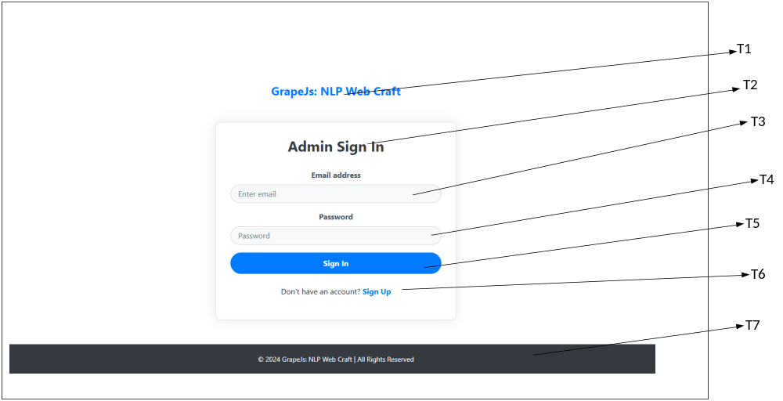

Element | Description
T1 | As an admin I shall view logo
T2 | As an admin I shall view Sign in page
T3 | As and admin I shall enter email id
T4 | As an admin I shall enter password
T5 | As an admin I shall click on sign in button
T6 | As an admin I shall click on sign up link
T7 | As an admin I shall View All rights reserved label.

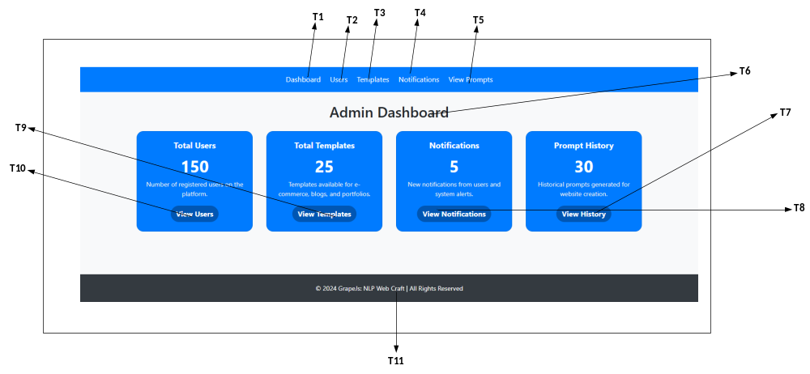

Element | Description
T1 | As an admin I shall click on dashboard.
T2 | As an admin I shall click on users.
T3 | As and admin I shall click on templates.
T4 | As an admin I shall click on notifications.
T5 | As an admin I shall click on view templates.
T6 | As an admin I shall view admin Dashboard label.
T7 | As an admin I shall click on view users.
T8 | As an admin I shall click on view templates.
T9 | As an admin I shall click on view notifications.
T10 | As an admin I shall click on View history.
T11 | As an admin I shall View All rights reserved label.

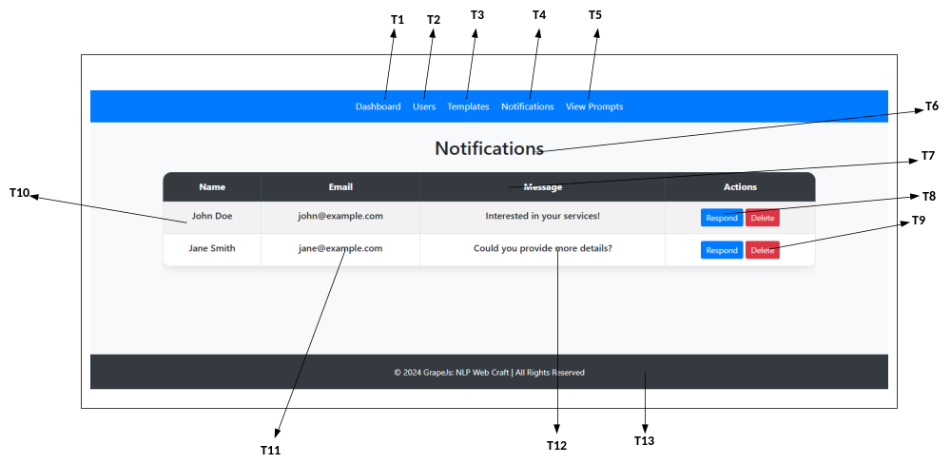

Element | Description
T1 | As an admin I shall click on dashboard.
T2 | As an admin I shall click on users.
T3 | As and admin I shall click on templates.
T4 | As an admin I shall click on notifications.
T5 | As an admin I shall click on view prompts.
T6 | As an admin I shall view Notifications label.
T7 | As an admin I shall click on view user description row.
T8 | As an admin I shall click on respond button.
T9 | As an admin I shall click on delete button.
T10 | As an admin I shall click on View user name.
T11 | As an admin I shall View user email.
T12 | As an admin I shall view user message.
T13 | As an admin I shall view all rights reserved label.

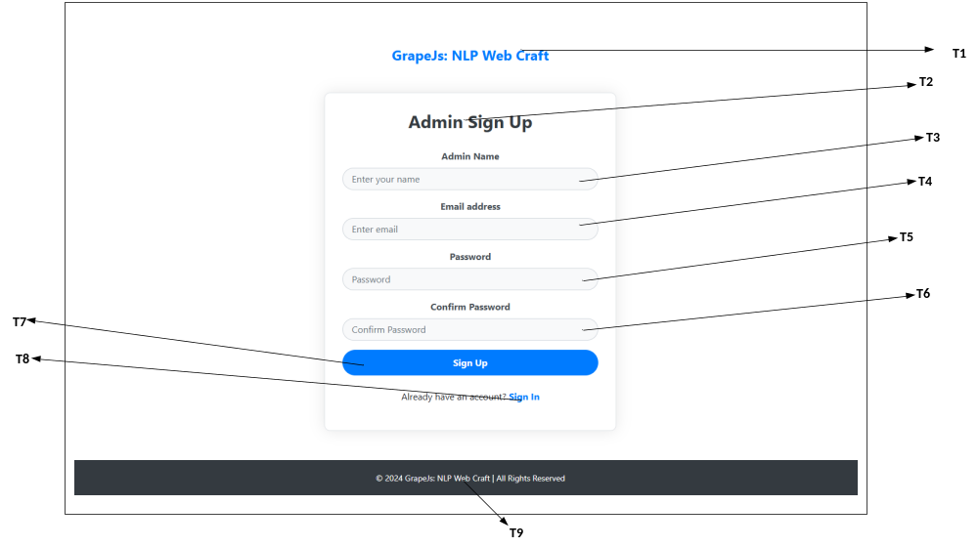

Element | Description
T1 | As an admin I shall view Grapejs Nlp Web Craft Label.
T2 | As an admin I shall view Sign Up page.
T3 | As and admin I shall enter name.
T4 | As an admin I shall enter email address.
T5 | As an admin I shall enter Password.
T6 | As an admin I shall enter confirm password
T7 | As an admin I shall click on sign up button.
T8 | As an admin I shall click on sign in link.
T9 | As an admin I shall view all rights reserved label.

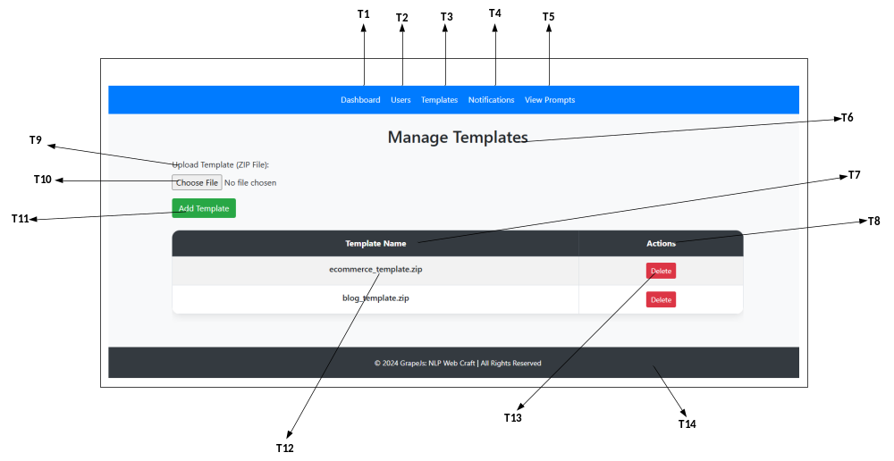

Element | Description
T1 | As an admin I shall click on dashboard.
T2 | As an admin I shall click on users.
T3 | As and admin I shall click on templates.
T4 | As an admin I shall click on notifications.
T5 | As an admin I shall click on view prompts.
T6 | As an admin I shall view Manage templates label.
T7 | As an admin I shall view Template name label.
T8 | As an admin I shall view action label.
T9 | As an admin I shall view upload template label.
T10 | As an admin I shall click on choose file button.
T11 | As an admin I shall click add template button.
T12 | As an admin I shall view template name.
T13 | As an admin I shall click on delete button.
T14 | As and admin I shall view all rights reserved label

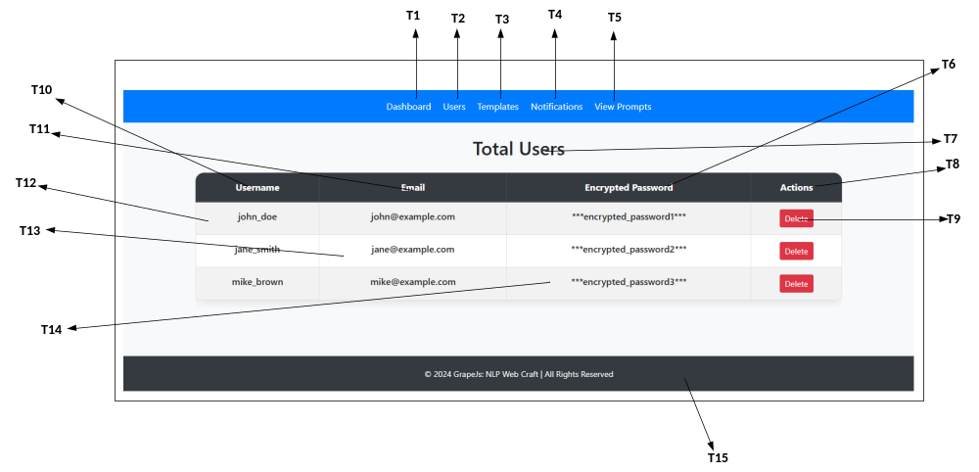

Element | Description
T1 | As an admin I shall click on dashboard.
T2 | As an admin I shall click on users.
T3 | As an admin I shall click on templates.
T4 | As an admin I shall click on notifications.
T5 | As an admin I shall click on view prompts.
T6 | As an admin I shall view encrypted password label.
T7 | As an admin I shall view Total Users label.
T8 | As an admin I shall view action label.
T9 | As an admin I shall click delete button.
T10 | As an admin I shall view username label.
T11 | As an admin I shall view Email label.
T12 | As an admin I shall view username.
T13 | As an admin I shall view Email.
T14 | As an admin I shall view encrypted password.
T15 | As an admin I shall view all rights reserved label.

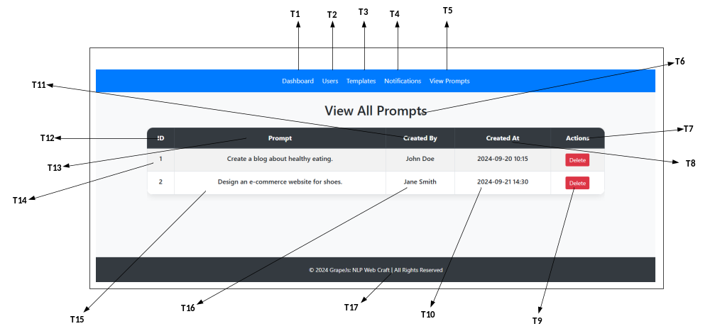

Element | Description
T1 | As an admin I shall click on dashboard.
T2 | As an admin I shall click on users.
T3 | As an admin I shall click on templates.
T4 | As an admin I shall click on notifications.
T5 | As an admin I shall click on view prompts.
T6 | As an admin I shall view all prompts label.
T7 | As an admin I shall view action label.
T8 | As an admin I shall view created at label.
T9 | As an admin I shall click delete button.
T10 | As an admin I shall view created at.
T11 | As an admin I shall view created by label.
T12 | As an admin I shall view ID label.
T13 | As an admin I shall view prompt label.
T14 | As an admin I shall view Id no.
T15 | As an admin I shall view prompt.
T16 | As an admin I shall view created by name.
T17 | As an admin I shall view all rights reserved label.

